**Walk 11 Knill and Offa’s Dyke**

Last walked in April 2017

**Description.** An 8 km (4.9 miles) Moderate walk with a very steep strenuous early climb through woods to reach Offer’s Dyke. Along open ground and a brook. Well maintained trails with great views. Taken from Hereford Times Feb 2012.

**Start.** Explorer Map 201 Grid 291604. Knill church.

**Direction from Whitecross roundabout** (Turn milometer to zero). Take the A438 towards Brecon. At 12.1 miles go straight on, heading towards Rhayader on the A44. At 12.6 miles carry straight on through Eardisley, heading towards Rhayader. At 18.2 miles go straight across roundabout, head towards Rhayader. Go straight across the next roundabout, (18.5 miles), head for Rhayader. At 22.3 miles TR and take the B4362 towards Presteigne. At 24.7 miles TR to Knill. After a short distance you go through the hamlet of Knill and the road bends L (24.9 miles), you continue straight on and up an unmarked tarmac drive to the church (25 miles).

**1.** **Knill Church of St Michael. *Knill is one of those rarest of British locations, a ‘thankful village’. The term ‘thankful village’ was coined in the 1930s to describe the handful of communities that suffered no military fatalities in the First World War. Between 1914 and 1918, there were no settlements in Scotland or Ireland that did not lose a member of the community, and only 52 parishes in England and Wales.*** Walk back down the church approach drive, on reaching the road you TR and walk along the road to cross over Hindwell brook ahead, via a concrete footbridge. Bend to the R and walk along the river bank for a short distance to TL and walk up a wide forest path that’s between the two houses. 80m beyond a green corrugated iron shed that is on your L, TL, and go up a public footpath quite steeply through the trees of KnillGarraway. Continue up a well marked track and along a line of trees to bend R when you get near to the top, to reach a marker post, Mortimer Trail path junction. TR for 35m to reach another marker post, and TL to continue up to cross over a stile/metal gate into a large field **{F1}**.

**2. Stile on upper, south edge of wood.** Keep to the L field edge to continue up hill to cross over another stile/metal gate into **F2**. Keep in the same direction and bearing away from the woods on your L, follow way marker posts to reach the Offer’s Dyke path on the brow of the hill and TR and follow Offa’s Dyke path. Go thru a metal gate into F3 and continue on to reach the corner of a wood (R). The path bends to the L and continues on, it starts to descend slightly to go thru a metal kissing gate into **F4**.

**3. Stile.** Continue to follow Offa’s Dyke path as it gradually descends, going to the L of woods. Go thru a small metal gate into open countryside. Continue in the same direction and after about twenty metres you bear L and follow the path down for 100m to reach the information board at the cross track junction. ***Welcome to Herrock Hill Common gives you information on Grazing, Offa’s Dyke, Butterflies and birds, Common land and Common care.*** TR, walk up, along and down Offa’s Dyke path, following way marker signs to contour the east side of Herrock Hill. Descend through a small/large metal gate and continue on down. The path reaches a junction, you continue in the same direction, along an enclosed track. You pass a sheep pen and small buildings on your L and go through a small/large metal gate. Continue on down to go through another small/large metal gate and 50m further on you go onto a driveway (house is L). Continue on down the driveway and at 150m you TR through a small wooden gate into **F5**. Cross over the field towards the far L hand corner to go through a small wooden gate and onto a wide farm track. Bear L and continue along the farm track to reach the main road.

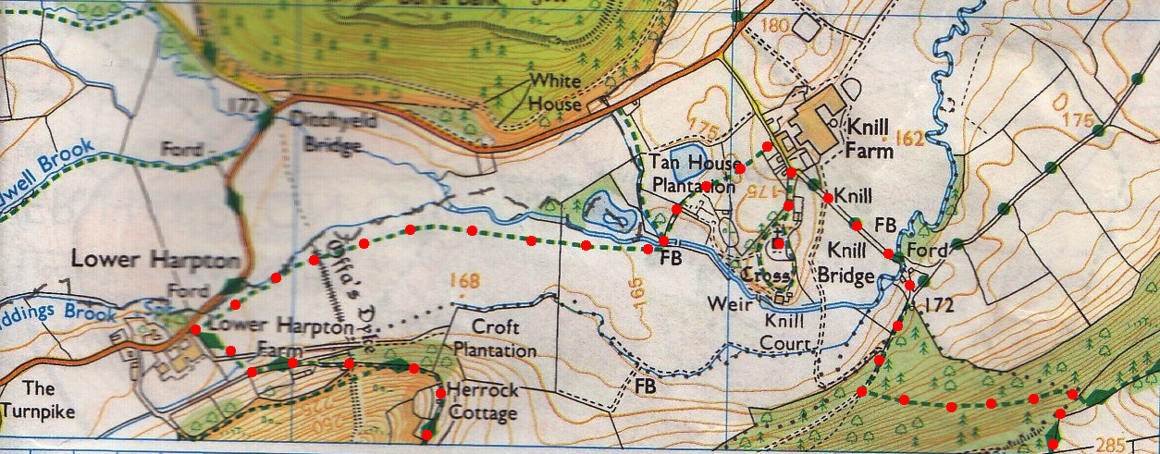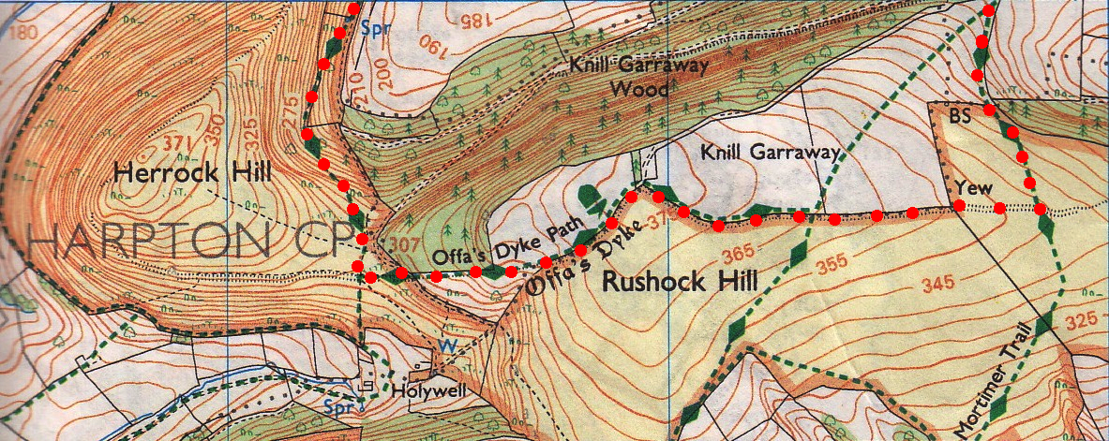**4. Riddings Brook.** Just before the main road you TR across a stile/metal gate into **F6**. Keep to the L field edge of this very large field, following the small brook that eventually joins a bigger brook called the Hindwell Brook. Cross a stile into the **F7** and keep to the L edge. Further on you TL and cross over a wooden footbridge across Hindwell Brook. Bear R and keep to the hedge on your R to go through a gap in the metal fence ahead and into **F8**. Bear slightly R and cross the field, keeping R of pond to go through a metal gate ahead, into **F9**. Bear slightly L to cross this field, to go through gate onto the road. TR, along road to where it bends L, go straight on and up to the church/car.

**4**

**2**

**1**

**3**